
Green University of Bangladesh
Department of Computer Science and Engineering (CSE)
Faculty of Sciences and Engineering
Semester: (Fall, Year:2024), B.Sc. in CSE (Day)

Lab Report NO # 10
Course Title: Engineering Drawing
Course Code: CSE-208 Section: 221-D2

Lab Experiment Name: Implementation of 3D drawing.

Student Details

Name |  | ID
1. | Md.Fahad Nakib | 221902149

Lab Date : 20-12-23
Submission Date : 12-01-24
Course Teacher’s Name : Md Naimul Pathan

Lab Report Status
Marks: ………………………………… Signature:.....................
Comments:.............................................. Date:..............................

- TITLE OF THE LAB EXPERIMENT
Implementation of 3D drawing.

2. OBJECTIVES
- To gain the basic knowledge of 3D modeling.
- To implement the skills to develop basic 3D drawings.

3. IMPLEMENTATION

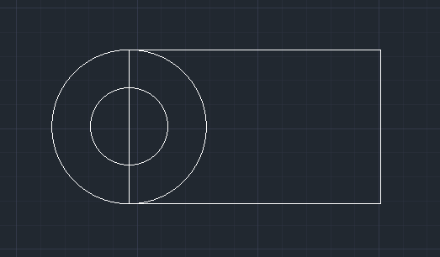
Figure: 01

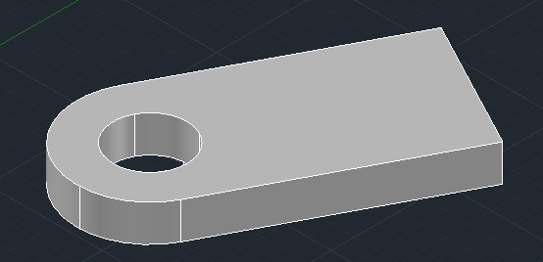
Figure: 02

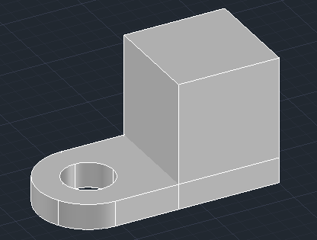

Figure : 03

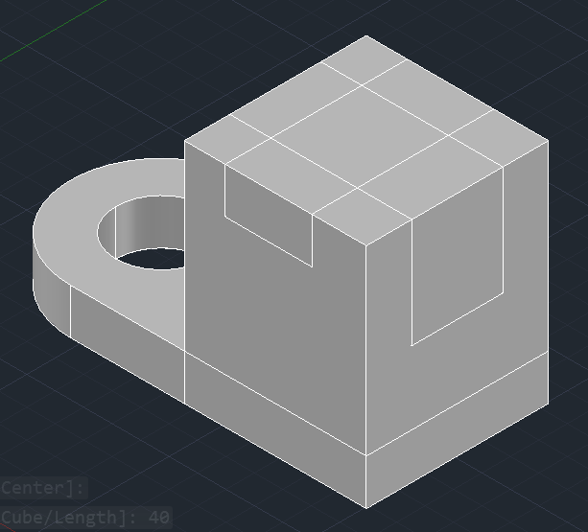
Figure : 04

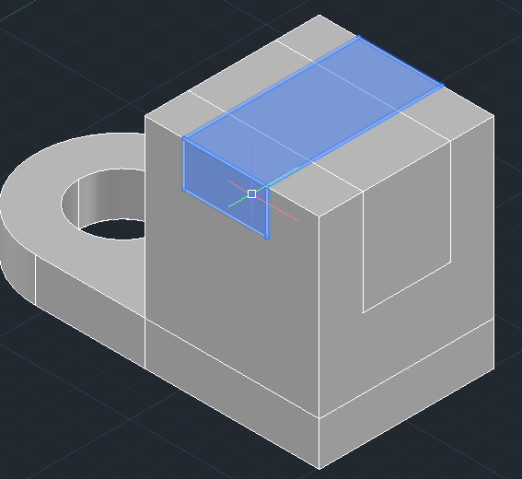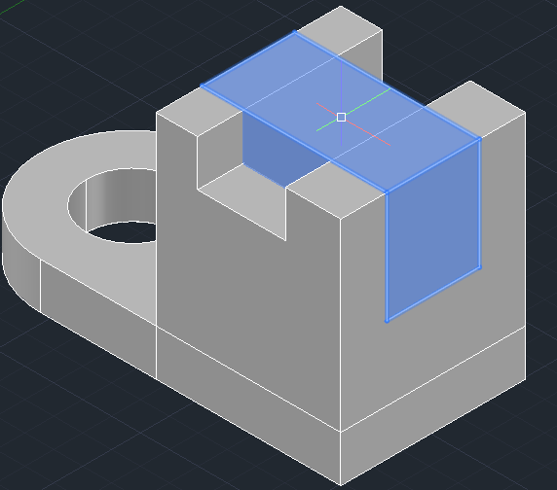

Figure: 05 Figure: 06

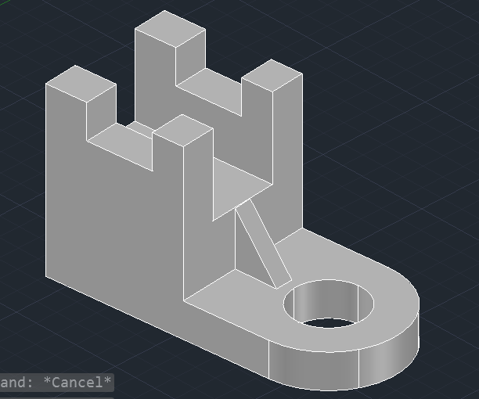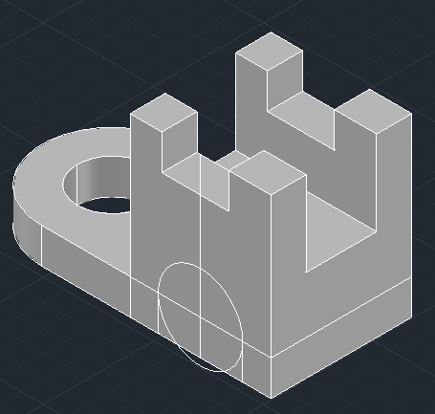

Figure: 07 Figure: 08

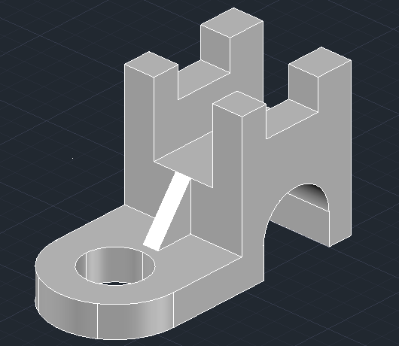
Figure: 09

6. FINAL OUTPUT

Figure: 10

7. ANALYSIS AND DISCUSSION
- This experiment helps us to learn about basic Auto Cad operations such as create press pull, move, copy, lines, circle, rectangle, etc.
- By this experiment we obtain the knowledge about 3D drawing technique and we can implement these tools to implement real life object.

